**Thakur Polytechnic**

**Department of INFORMATION TECHNO.**



**SYIF – Semester – 4**

**[2024-2025]**

**SUBJECT: INTERNET OF THINGS**

**62. Suhani divekar**

**63. Laxman Gupta**

**69. Tejas Ahire**

**GUIDED BY – MRS. KIRAN PATIL**



**MAHARASHTRA STATE BOARD OF TECHNICAL EDUCATION.**

This is to certify that the following group of students roll nos. **65-67** of **4TH Semester**

of **Diploma in Information Technology** of institute, **THAKUR POLYTECHNIC** **(Code:0522)** has completed **Micro-Project** satisfactory in subject – Internet Of Things for the academic year 2024-2025 as prescribed in curriculum.

Names of the members, roll numbers & enrollment numbers:

|  |  |  |
| --- | --- | --- |
| Roll Number | Name | Enrollment Number |
| 62 | **Suhani divekar** | 24151460667 |
| 63 | **Laxman Gupta** | 24151460666 |
| 69 | **Tejas Ahire** | 24151460661 |

Place: Mumbai

Date: April 2025

Subject Teacher Head of Department Principal

Institution Seal

**ACKNOWLEDGEMENT**

We feel immense pleasure in submitting this report on “Smart Distance Sensor with Real-Time Buzzer Alert” While submitting this report, we avail this opportunity to express our gratitude to all those who helped us in completing this task. Heading the list with our own honorable Principal Dr. S. M. Ganechari who is the beginner of our inspiration.

We owe our deep gratitude and are also very thankful to our guide

Mrs. Kiran Patil and HOD Ms. Suwarna who has proven to be more than just a mere guide to us. Apart from bringing to us what can be joy of successful completion of this project was only possible due to her guidance and co-operation without which this work would never have been completed.

Finally, we wish to express our deep sense of respect and gratitude to each and every staff member who has helped us in many ways and also our parents who have always bared with us in any critical situation and to all others, sparing their time and helping us for completion of this project in whatever way they could. And lastly, we are grateful to each other member of our group.

Thank you!

# **PROPOSAL**



## Title: “Obstacle Detection and Distance Measurement System Using Ultrasonic Sensor and Buzzer”

### **1. Aim/Benefits of the Project-**

The aim of this project is to design and implement a system that can accurately measure the distance between a sensor and an object using an ultrasonic sensor and trigger a buzzer when an obstacle is detected within a specified range. This system serves as a basic prototype for proximity detection and alert systems.

* **Accident Prevention:** Helps in avoiding collisions by providing early alerts when objects are nearby.
* **Low Cost:** Utilizes inexpensive and easily available components, making it budget-friendly.
* **Easy to Implement:** Simple circuit design and programming, suitable for beginners in electronics and embedded systems.
* **Versatile Applications:** Can be used in robotics, automation, parking assistance systems, blind spot monitoring, and more.
* **Educational Value:** Enhances understanding of sensors, microcontrollers, and real-time alert mechanisms.

**2. Course Outcomes Addressed-**

1) **Apply basic knowledge of sensors and embedded systems**

### Demonstrated by integrating an ultrasonic sensor and buzzer to detect obstacles and provide real-time alerts.

2) **Design and analyze simple electronic circuits**

* Achieved through designing a working circuit involving microcontroller, sensor, and output devices.

### 03) **Develop basic programming skills for microcontroller-based systems**

### Implemented by writing code to measure distance and trigger the buzzer when a threshold is reached.

### 04) **Demonstrate problem-solving skills in designing low-cost, real-time systems**

### Shown through the development of a cost-effective and efficient obstacle detection prototype.

### **O5) Understand real-world applications of embedded systems**

### Realized by applying the project in areas such as parking assistance, automation, and safety devices.

### 3. **Proposed Methodology-**

To complete this micro-project of Arduino the procedure that we will follow is given below –

• **Research on Distance Measurement Techniques:**  
Study various distance sensing technologies with a focus on ultrasonic sensors for accurate obstacle detection.

• **Study of Ultrasonic Sensor and Alert Mechanisms:**  
Understand the working principles of the HC-SR04 ultrasonic sensor and buzzer for real-time proximity alerts.

• **Circuit Design and Hardware Implementation:**  
Design the circuit by connecting the ultrasonic sensor and buzzer to the Arduino board and assemble the hardware setup.

• **Programming Arduino for Sensor and Buzzer Control:**  
Write and upload Arduino code to calculate distance from the sensor and activate the buzzer when an object is detected within a set range.

• **Testing and Troubleshooting:**  
Test the system in different scenarios to verify accuracy and reliability, and troubleshoot any hardware or code issues.

• **Report Preparation and Final Presentation:**  
Document the entire project process, including circuit diagrams and code explanation, and prepare for final presentation and demonstration.

### **4. Action Plan**

|  |  |  |  |
| --- | --- | --- | --- |
| **Sr. No.** | **Details of Activity** | **Planned Finish Date** | **Name of** **Responsible**  **Team Member** |
| 1. | Information Search | 08/03/2025 | Laxman Gupta |
| 2. | Group Discussion | 06/03/2025 | All group members |
| 3. | Group Discussion | 12/03/2025 | All group members |
| 4. | Taking reference | 15/03/2025 | Suhani Divekar |
| 5. | Execution | 24/03/2025 | Tejas Ahire |
| 6. | Compilation of reports | 05/04/2025 | Laxman Gupta |
| 7. | Presentation and report submission | 10/04/2025 | All group members |

### **5. Resources Required**

|  |  |  |  |
| --- | --- | --- | --- |
| **Sr.No.** | **Name of**  **Resources** | **Quantity** | **Remarks** |
| 1. | Arduino Uno | 1 | Available |
| 2. | breadboard | 1 | Available |
| 3. | LED | 1 | Available |
| 4. | piezo speaker | 1 | Available |
| 5. | Ultrasonic sensor | 1 | Available |
| 6. | Jumper wires | 15 | Available |
| 7 | Resistors | 3 | Available |

|  |  |  |
| --- | --- | --- |
| Roll Numbers of Team Members | the | Names of the Team Members |
| 62 |  | Suhani Divekar |
| 63 |  | Laxman Gupta |
| 69 |  | Tejas Ahire |

Mrs. Kiran Patil

(Subject Teacher)

# REPORT



1.0) **Rationale**

In many applications such as robotics, automation, and safety systems, the ability to detect obstacles and measure distance accurately is essential. Collisions due to undetected obstacles can lead to damage or accidents. This project aims to develop a low-cost, efficient system that uses an ultrasonic sensor to measure the distance between the sensor and nearby objects. When an object is detected within a predefined range, a buzzer is triggered to alert the user, enhancing awareness and safety in real-time.

2.0) **Aim/Benefits of the micro-project**

To design and develop a simple, cost-effective obstacle detection system using an ultrasonic sensor that measures the distance to nearby objects and activates a buzzer when an obstacle is detected within a specified range.

* **Cost-Effective Solution:**  
  Uses affordable and readily available components, making it suitable for low-budget applications.
* **Hands-On Learning:**  
  Enhances practical knowledge of sensors, actuators, and microcontroller programming.
* **Real-Time Feedback:**  
  Offers immediate alerts through a buzzer, allowing timely response to obstacles.
* **Wide Range of Applications:**  
  Can be applied in parking assist systems, robotics, automation, and security alarms.
* **Scalable Design:**  
  The system can be expanded to include additional sensors or integrated into larger systems.

3.0) **Course Outcomes Achieved**

**O1 – Apply knowledge of sensors and embedded systems**  
Successfully integrated an ultrasonic sensor and buzzer with a microcontroller to detect obstacles and provide real-time alerts.

**O2 – Design and implement basic electronic circuits**  
Designed and assembled a functional circuit that interfaces input (sensor) and output (buzzer) devices with Arduino.

**O3 – Develop microcontroller-based programming skills**  
Wrote and uploaded Arduino code to measure distance and trigger a buzzer based on the sensor's input.

**O4 – Demonstrate problem-solving and debugging skills**  
Identified and resolved issues during hardware setup and code execution to ensure the system worked accurately and reliably.

4.0) **Literature Review**

**Challenges in Object Detection and Collision Prevention:**

* **Lack of Awareness:**

In robotic systems or automated devices, undetected obstacles can lead to collisions and damage.

* **Limited Human Response Time:**

Manual monitoring is not always reliable for quick detection in dynamic environments.

* **High-Cost Alternatives:**

Advanced detection systems like LIDAR can be expensive and complex to implement in simple projects.

**Engineering Solution with Sensor-Based Alert System:**

* **Ultrasonic Sensing:**

HC-SR04 sensor uses sound waves to measure distance, providing a non-contact method for obstacle detection.

* **Real-Time Distance Monitoring:**

Continuously calculates the distance between the sensor and nearby objects with high accuracy.

* **Buzzer Alert Mechanism:**

**A buzzer is activated when an object is detected within a set range, alerting users instantly.**

* **Low-Cost, Scalable Design:**

Utilizes simple, affordable components, making it ideal for educational and prototype development.

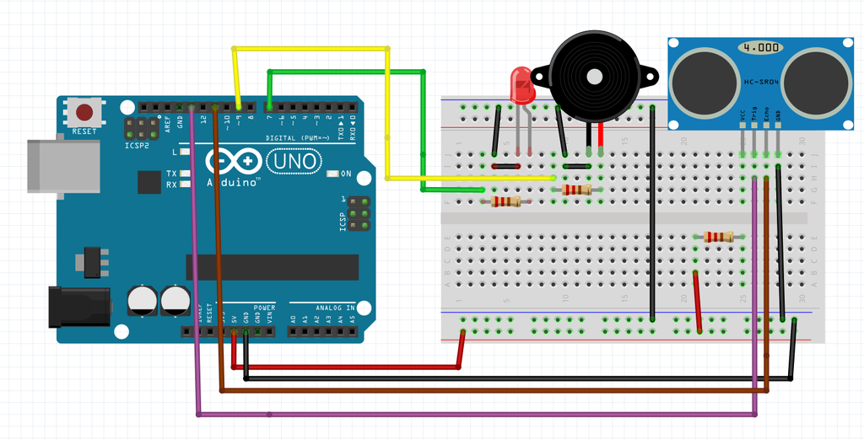5.0) **Circuit Diagram**

6.0) **Components Required**

1. 1 Arduino board
2. 1 breadboard
3. 1 LED
4. 1 piezo speaker
5. 1 Ultrasonic sensor
6. Jumper wires
7. Resistors

7.0) **Connections**

1) Add the LED to the breadboard. Connect the short leg of the LED to Ground, long leg of LED to pin 7 with jumper wires and resistors shown in the diagram.

2) Add the piezo speaker to the breadboard. Connect the short leg of the piezo speaker to Ground, long leg to pin 9 with jumper wires and resistors shown in the diagram.

3) Add the ultrasonic sensor to the breadboard. There are 4 pins in the ultrasonic sensor. They are Vcc (5V power supply), Trig (Trigger), Echo, Gnd (Groud). Connect Vcc to 5V power supply, Gnd to Ground, Echo to pin 13, Trigger to pin 11 with jumper wires and resistors shown in the diagram.

📌 **Make sure your solenoid lock is powered correctly (12V or 5V) as required**.

8.0) Code of the Program

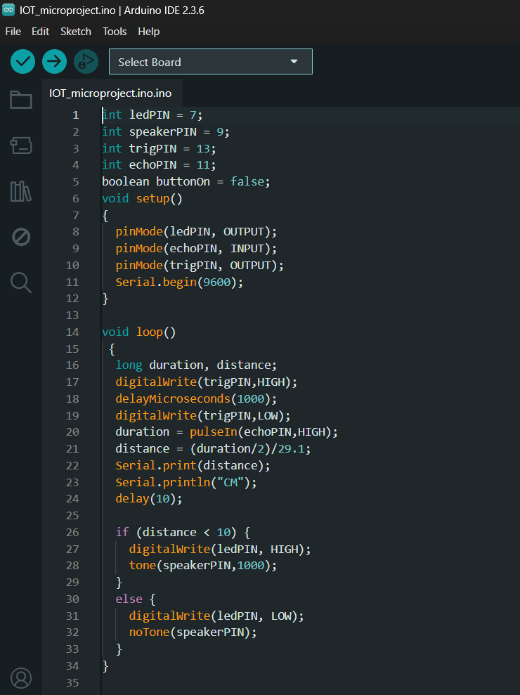

**9.0) Uploading & Testing the Code**

📌 **Step 1: Upload the Code**  
⿡ Open the **Arduino IDE**  
⿢ Copy & paste the updated obstacle detection code  
⿣ Connect the Arduino board to your PC via USB  
⿤ Select the correct **Board** and **COM Port** under the **Tools** menu  
⿥ Click the **Upload ▶** button to upload the code to the Arduino

📌 **Step 2: Open Serial Monitor**  
⿡ Click the **Serial Monitor** icon in the top-right corner of the Arduino IDE  
⿢ Set **Baud Rate to 9600**  
⿣ Observe the distance readings printed in real-time  
⿤ Move objects in front of the sensor to verify distance detection

📌 **Step 3: Test Buzzer and LED Alert**  
⿡ Place an object within the specified range (e.g., less than 10 cm)  
⿢ Confirm that the **LED turns ON** and the **buzzer sounds**  
⿣ Remove the object and ensure that the LED and buzzer turn **OFF**  
⿤ Adjust the threshold in the code if needed for different detection ranges

**10.0) How It Works?**

✅ **Step 1:** The **ultrasonic sensor (HC-SR04)** continuously sends out sound waves to detect the presence of an object in front of it.  
✅ **Step 2:** When the sound wave reflects back from an obstacle, the sensor calculates the **distance** based on the time taken for the echo to return.  
✅ **Step 3:** The calculated distance is compared with a **preset threshold** (e.g., 10 cm) in the code.  
✅ **Step 4:** If the object is detected **within the threshold distance**, the **LED turns ON** and the **buzzer activates**, indicating an obstacle nearby.  
✅ **Step 5:** If there is **no obstacle** or the object is **beyond the threshold**, the **LED turns OFF** and the **buzzer remains silent**.

**11.0) Troubleshooting**

🔴 **Problem: No distance reading in Serial Monitor**  
✔ **Solution:** Check the **wiring of the HC-SR04** sensor. Make sure **Trig** and **Echo pins** are connected to the correct Arduino digital pins. Also, verify that **Baud Rate** is set to **9600** in the Serial Monitor.

🔴 **Problem: LED and buzzer not turning on even when an object is close**  
✔ **Solution:** Confirm that the object is within the set threshold distance (e.g., 10 cm). Adjust the threshold value in the code if needed. Also, check if the **buzzer and LED** are connected to the correct pins and not damaged.

🔴 **Problem: LED or buzzer always on**  
✔ **Solution:** There may be **false triggering** due to interference or incorrect wiring. Check the **sensor alignment** and ensure that there is no object constantly within the detection range. Try increasing the threshold or using distance > 0 && distance < 10 logic in the code.

🔴 **Problem: Buzzer makes very low or no sound**  
✔ **Solution:** Make sure you're using a **piezo buzzer**, not a passive one (unless handled correctly in code). Also, verify the buzzer is connected properly and not reversed in polarity.

**12.0) Future Enhancements**

🚀 **Add LCD Display for Distance Output**  
→ Show real-time distance measurements on a 16x2 or OLED display for better visualization.

🚀 **Integrate WiFi/Bluetooth Connectivity**  
→ Send distance data wirelessly to a mobile device or cloud platform for remote monitoring and data logging.

🚀 **Use a Mobile App for Alerts**  
→ Develop a basic mobile app to receive alerts when an obstacle is detected within a critical range.

🚀 **Implement Adaptive Threshold Logic**  
→ Allow the system to auto-adjust detection range based on environment or user input via a button or app.

🚀 **Add Multiple Sensors**  
→ Enhance the system by using multiple ultrasonic sensors to cover wider or multiple directions.

**13.0) Outputs of the Microproject:**

✅ A **working prototype** of an obstacle detection system using an ultrasonic sensor and buzzer alert.

✅ Gained **practical knowledge of sensor interfacing** and real-time distance measurement using Arduino.

✅ Improved understanding of **embedded system applications** in safety, automation, and proximity alert systems.

✅ Demonstrated ability to **design, code, and troubleshoot** microcontroller-based hardware projects.

**14.0) Skill Developed / Learning Outcome:**

✅ Understanding of **ultrasonic sensing principles** and real-time distance measurement.

✅ Hands-on experience in **Arduino programming and sensor interfacing**.

✅ Ability to **design and implement embedded systems** for obstacle detection and alert mechanisms.

✅ Improved **problem-solving, teamwork, and project execution** skills through collaborative development.

**15.0) Applications of Microproject:**

A micro-project helps students develop practical skills through collaborative work, enabling them to tackle real-world problems effectively. From this microproject, we learned how to interface sensors with microcontrollers, measure distance using ultrasonic waves, and implement a simple alert system based on proximity detection. This system can be applied in various fields such as:

✅ **Automatic obstacle detection** in robots and smart vehicles

✅ **Parking assistance systems**

✅ **Industrial safety systems** to detect nearby machinery or objects

✅ **Assistive tools** for the visually impaired

**16.0) Overview / Conclusion:**

In summary, this **Ultrasonic Obstacle Detection System** offers a simple, efficient, and low-cost solution for detecting nearby objects and alerting users in real time. By utilizing an **ultrasonic sensor with Arduino**, the system accurately measures distance and activates a **buzzer and LED alert** when an obstacle is detected within a specified range. This project enhances practical skills in **sensor integration, embedded systems, and real-time automation**, and it serves as a foundational model for more advanced applications such as **robotics, automation, and safety systems**.

Mrs. Kiran Patil

(Subject Teacher)